**GROUP DISCUSSION**

**ESSENTIALS OF GD**

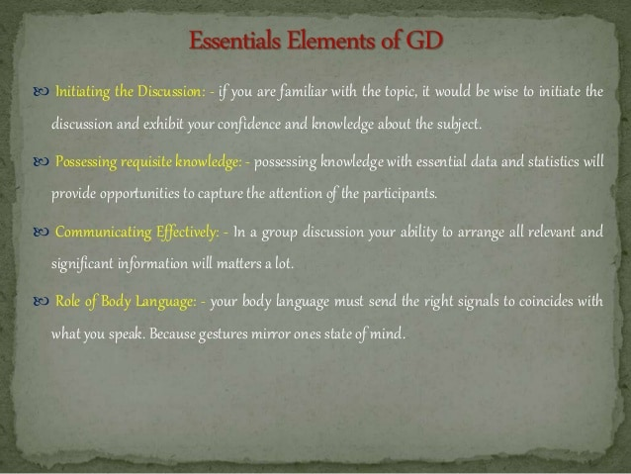

**TYPES OF GD**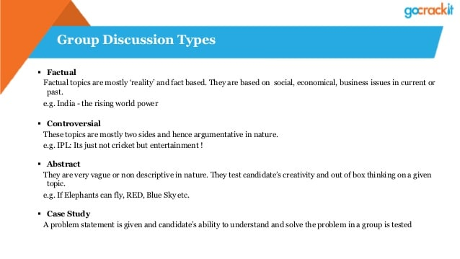

LANGUAGE OF GD

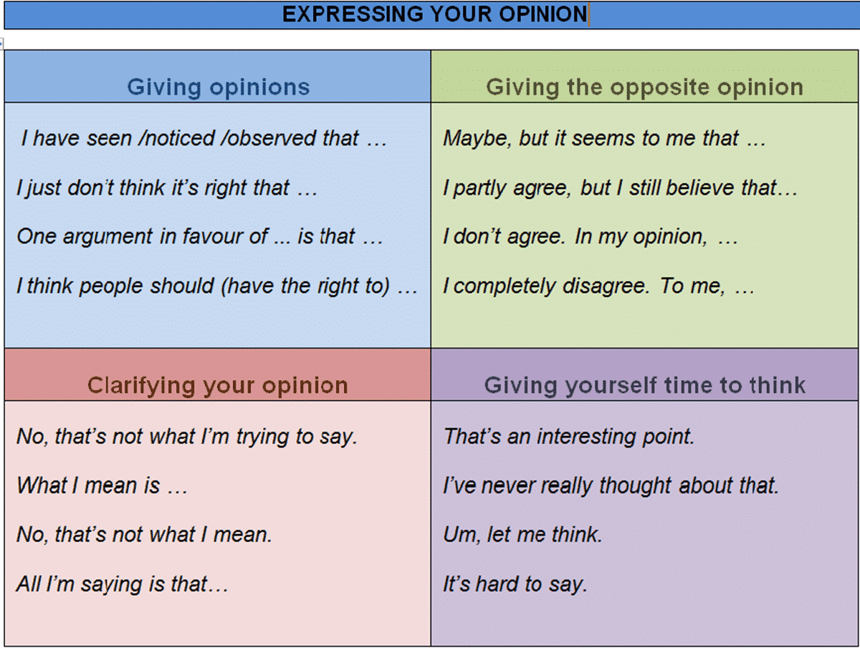

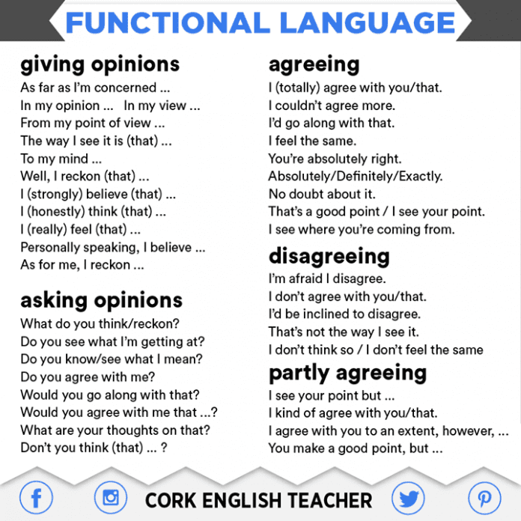

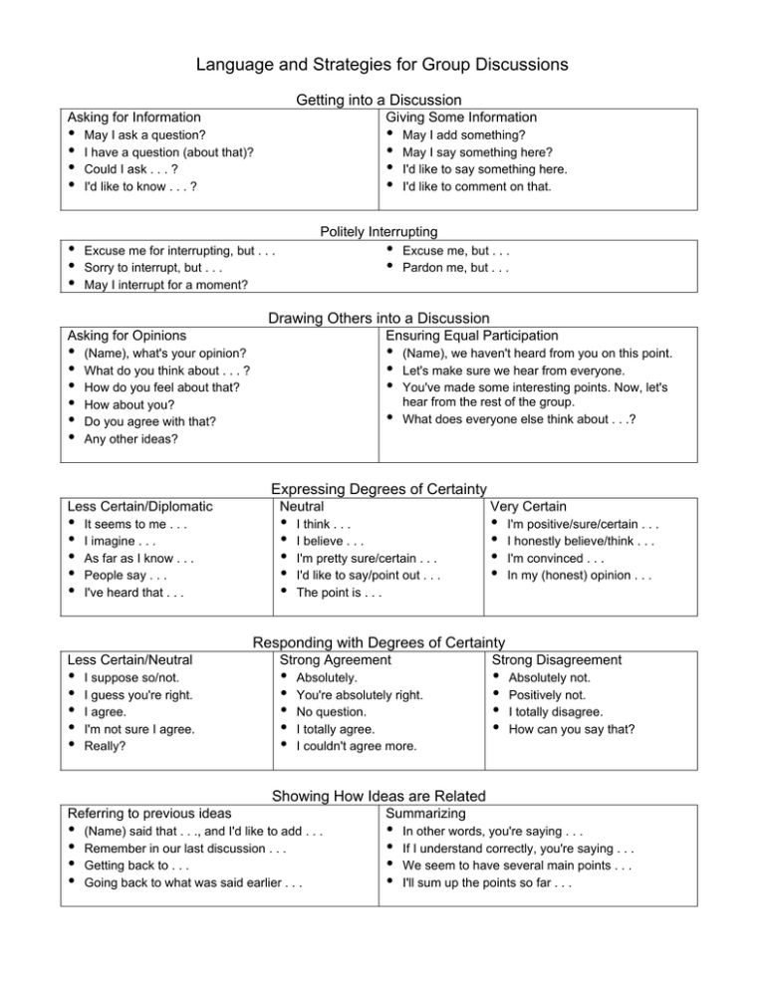

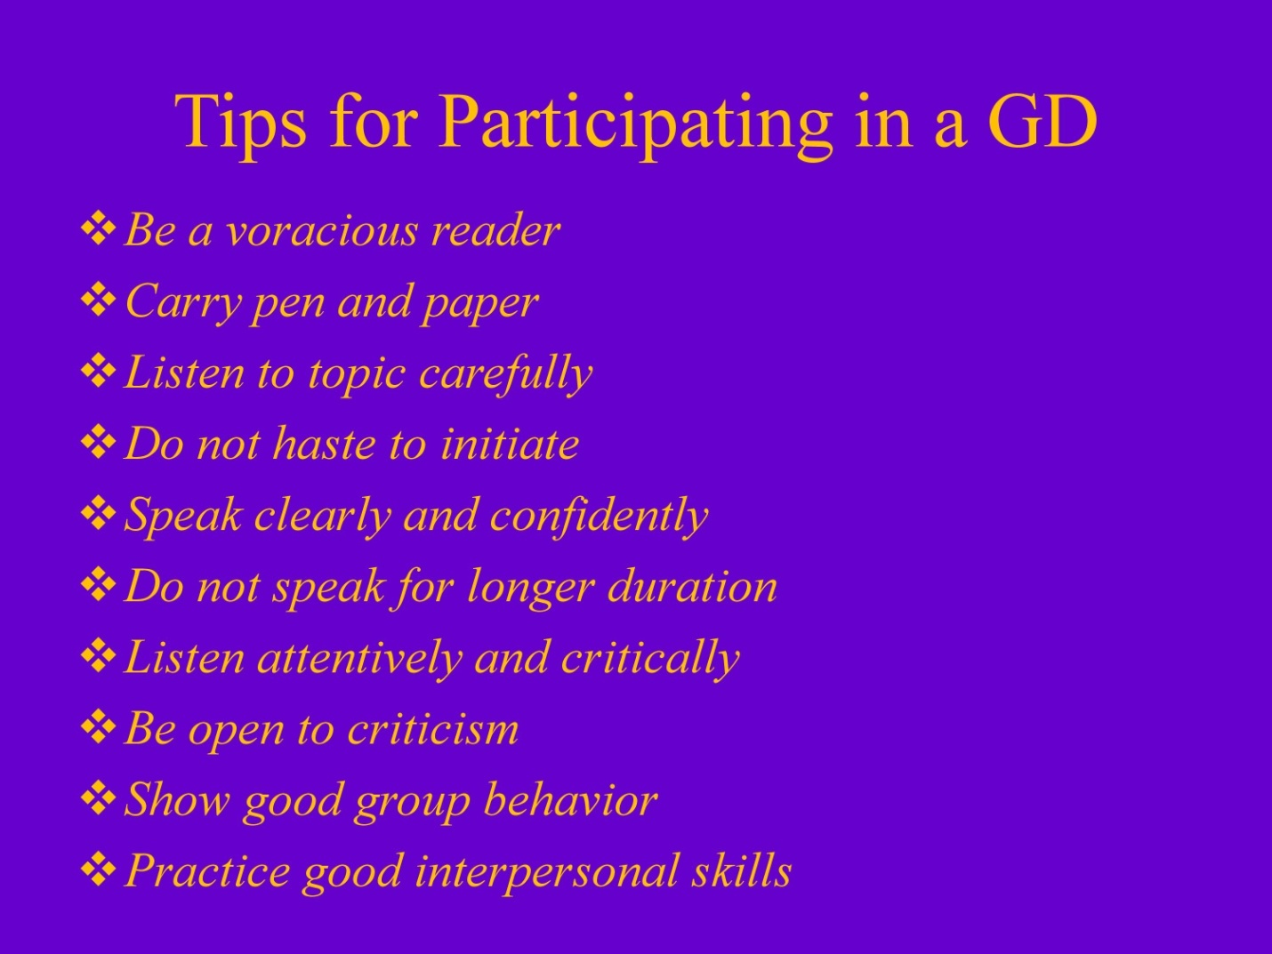

**How does one present?**  
  
A good presentation is impressive in a group discussion.

* The presenter must have a body language that is very expressive and not offensive. This shows that the speaker doesn’t lack mannerism.
* The presenter must have a direct eye contact with the team mates. This shows confidence.
* Presentation is not just about the material but your own self. The way you dress is an important aspect of presentation.

**I feel you are wrong.**

**Believe**

**Consider**

**suppose**

**Faith**

**It is my opinion**

**Scientific opinion/ opinion of the scientific community**

